ADITYA COLLEGE OF ENGINEERING



**VALASAPALLE ROAD,MADANAPALLE**

### DEPARTMENT OF ELECTRONICS AND COMMUNICATION ENGINEERING

#### S mart Dus tbin Us ing With NodeMCU

presented by

**Y.jagadeeshwarreddy**

## Introduction to Smart Dus tbin

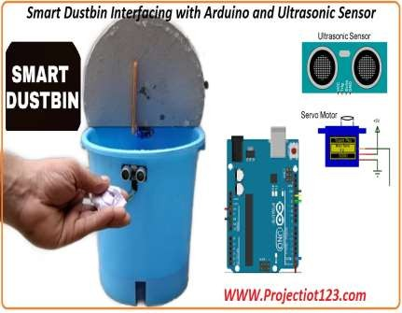

The smart dustbin is an innovative solution to improve waste management.

It integrates IoT technology to monitor and manage waste levels effectively.

This system aims to enhance cleanliness and

promote recycling initiatives.

# Overview of NodeMCU

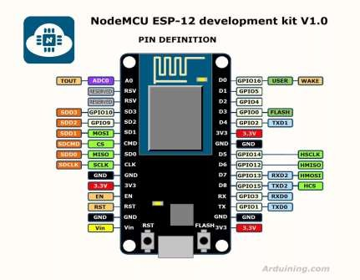

NodeMCU is an open-source IoT platform based on the ESP8266 Wi-Fi module.

It allows for easy programming using the Lua script or Arduino IDE.

Its low cost and compact size make it ideal

for smart applications.

## Components Required

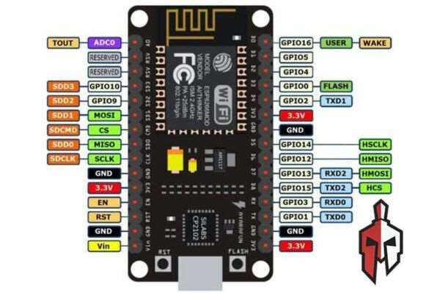

The primary components include NodeMCU, ultrasonic sensors, and a Wi-F i module.

Additional components include a servo motor for lid operation and a power supply.

A breadboard and jumper wires are also

essential for circuit connections.

## Working Principle

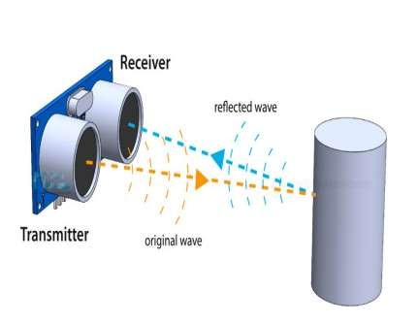

The ultrasonic sensor measures the level of waste in the dustbin.

When the waste level exceeds a certain thres hold, the NodeMCU activates the servo motor.

The servo motor opens the lid, allowing

users to dispose of waste easily.

## Data Trans mis s ion

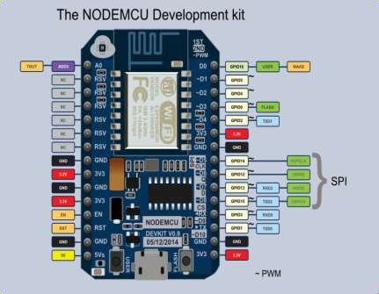

The NodeMCU connects to the internet via Wi-Fi for real-time data transmission.

It can send alerts or notifications to users when the dustbin is full.

This feature helps in efficient waste

collection scheduling by municipal services.



|  |  |
| --- | --- |
| Benefits of Smart Dus tbin | |
| Smart dustbins reduce overflow and unsightly litter in public areas.  They promote recycling by encouraging proper waste disposal practices.  The data collected can be used to analyze  waste generation trends. |  |
|  | |

## Challenges Faced

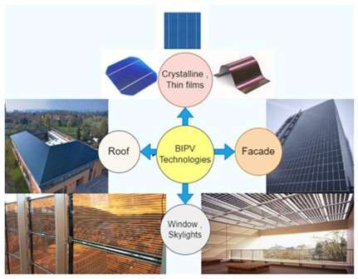

Ensuring the durability and weather resistance of the electronic components is crucial.

Connectivity issues in remote areas may hinder data transmission.

R egular maintenance is required to keep the sensors and motors functioning effectively.

# Future Enhancements



Future versions could incorporate solar panels for self-sustainability.

Integration with AI could help in sorting waste automatically.

Enhanced user interfaces can provide better

interaction and feedback.

# Real-world Applications

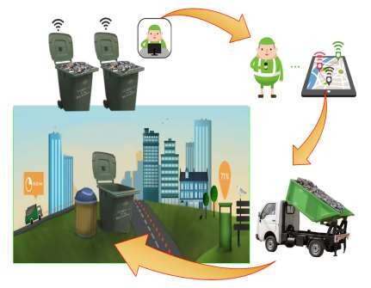

Smart dustbins can be deployed in urban areas, parks, and public spaces.

They can be integrated into smart city initiatives for better resource management.

Educational institutions can use them to instill waste management awareness among students.

# Conclusion

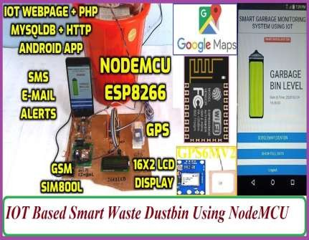

The smart dustbin with NodeMCU is a step towards smarter waste management.

Its implementation can lead to cleaner and more sustainable environments.

Continued innovation in this field can

significantly impact urban living standards.

# References



"NodeMCU Documentation," NodeMCU. "IoT Waste Management," IoT For All. "Smart Dustbin Project," Electronics Hub.

Feel free to adjust any details or add visuals

to enhance the presentation!

**RESULT**



<https://github.com/123456789jagga/project>